
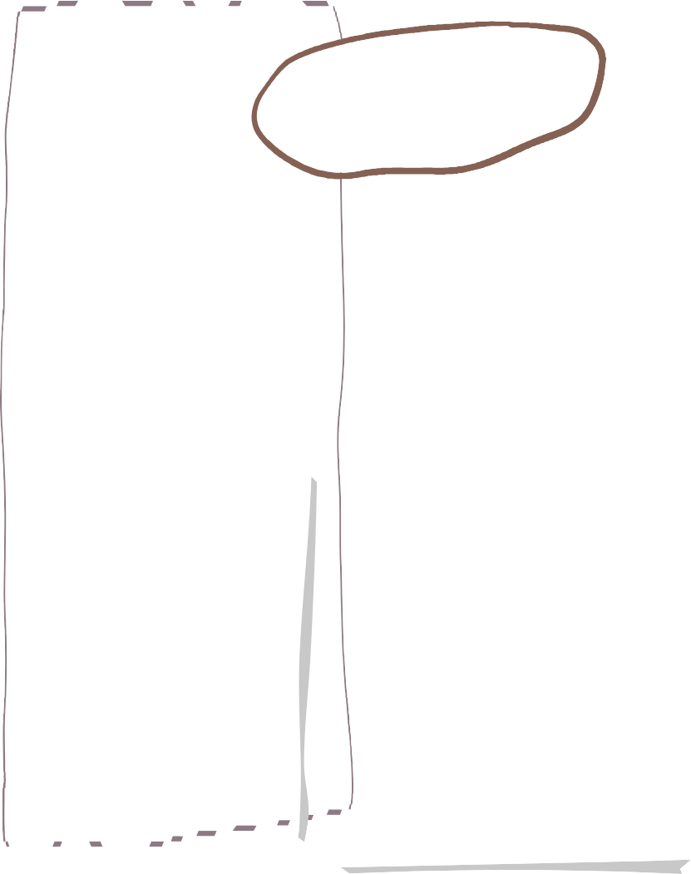



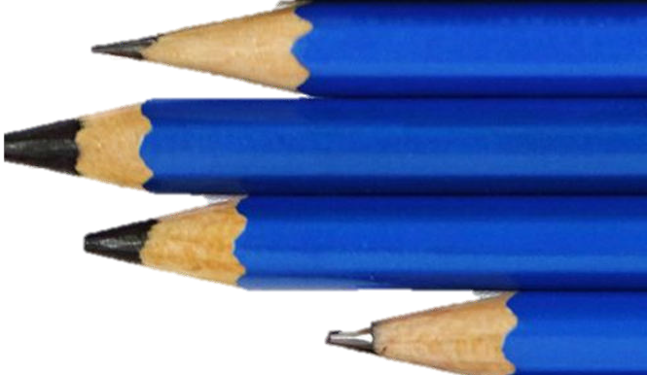

Children will be encouraged to write independently to support their transition to Year 1.

Children will be encouraged to use capital letters, full stop, finger spaces and their phonological knowledge to write sentences.

Your child/children will continue to practice their reading on Tuesday, Wednesday and Thursday. Please can we kindly ask that you read this book with your child/children at home. Please can we also ask that these books are returned to us by the following Monday, so that they can be reallocated to other children and your child can be given a new book.

Unfortunately, if your child’s previous reading is not returned, your child will not receive another book.

We have officially learnt all the sounds that the children must learn in Reception! We will now be using these sounds to read longer words and new tricky words.

We will also be reading and writing sentences.
During this half-term, we will be reconsolidating our knowledge of number bonds of numbers up to 10.

In addition to this, we will be learning about 2D and 3D shapes.
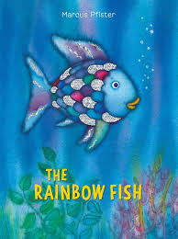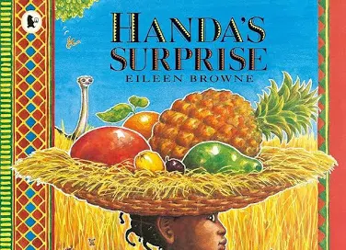
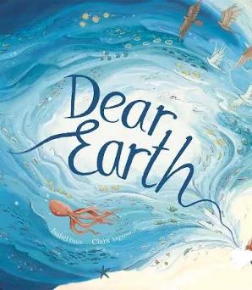

Reading

Summer 2 - Reception
We are reading…
Phonics
Number
Writing




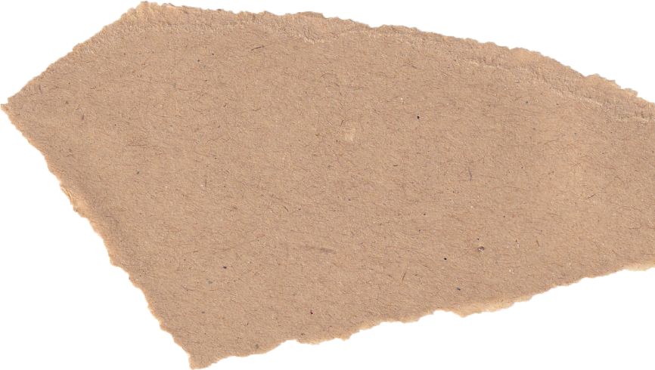


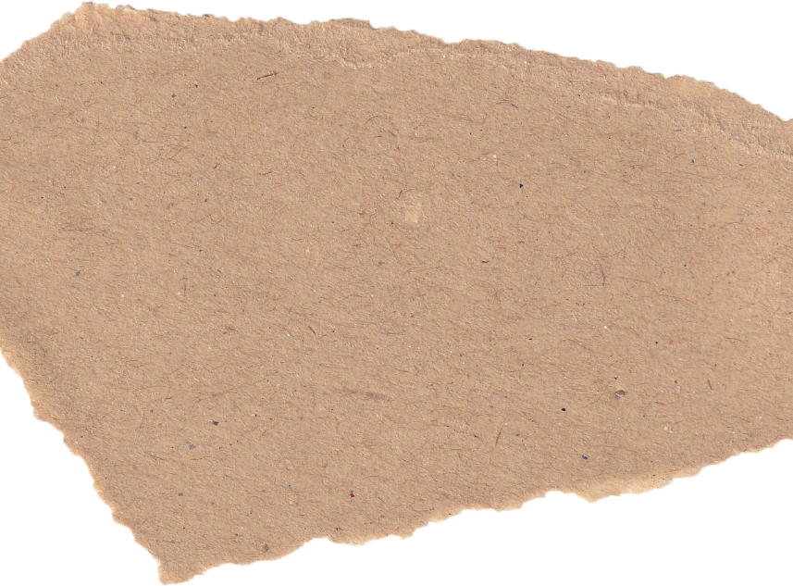
Our EYFS Team:

Sparrows – Miss Dellar teaches Wednesday – Friday (EYFS Lead) and Mrs Wells teaches Monday and Tuesday.

Merlins – Miss Decker.

Mrs Button supports both classes.

Mrs Johnson, Mrs Butler, Mrs Port and Miss Medlow, also support our classes on different days.
Our PE day is on Thursday afternoon. The children can now come into school wearing their PE kit so that they can make the most of the PE lessons.

We also have a free-flow PE shed full of fun activities that children can use in provision to support their physical development.
KEY DATES:
Wednesday 3rd June – Trip to Shepreth wildlife park.
Friday 5th June – World Cup Dress up day – dress up in the colour of your allocated country’s flag.
Tuesday 9th June – Ash Randall Football Freestyler coming to visit.
Wednesday 17th June – Sports Days – Lower school - 1:15pm-3:00pm.
Friday 19th June – Father’s Day Gift Event
Wednesday 24th June – Reserve Sports Day – Lower School 1:15-3:00pm.
Monday 29th June – STAFF TRAINING DAY – SCHOOL CLOSED.
Wednesday 8th July – Little Paxton School Festival – 3:30-5:30pm.
Tuesday 14th July – Current teacher’s parents evening – 3:40pm-5:30pm.
Wednesday 15th July – Meet your new teacher – 3:30-5:00pm.
Friday 17th July – Headteacher’s award – 9:05am Lower school

Other key dates nearer the time will be put on the weekly Paxton Press and we shall send reminders on Dojo!

We will continue to be learning about different aspects of Expressive Arts and Design such as role play and singing a range of nursery rhymes.

This half-term we will be focusing on Music. We will be learning and performing songs using our voices and musical instruments. The songs we will be learning are called ‘Down there under the sea’ and ‘Slap clap, clap’.

In Understanding the World this half-term, we will be learning about the UK and comparing it to other countries and the rest of the world.

In Personal, Social and Emotional Development we will supporting the children with their transition to Year 1. We will be sharing stories about change and discussing things that they can do and people they can talk to if they have worries about the change.
Messages
UTW
Other things to note
PSED
PE
EAD

